**Next-Door Delivery Application Documentation**

**Developing Team:**

**Name Position**

Antonio, Matt Jeanne -          Business Analyst and Programmer

Casillan, Jan Nicole - Programmer and QA

Manicar, Juan Paolo       -           Project Manager

Martinez Cristopher - Programmer

Ortiz Jayra Gaile - Data Analyst and Main Programmer

1. **System Name:** The Good Company – Next Store Delivery Essentials
2. **Description:**

The Next Store Delivery or simply put the Food Delivery Essentials helps cater the needs of people buying essential items in pursuit of looking for the nearest quality stores for them to buy their respective needs like raw goods, essentials, and packed goods. This has the option to deliver door-to-door or simply let the user fetch the delivery to their available time to increase the quality time spent of the user to other activities that need his/her attention as well as help the user on a budget cater their needs without spending much.

1. **Problem Statement/s:**
2. In a new normal system, more and more people have realized that food delivery and essentials have a huge impact of saving their time looking for an alternative to choose from.
3. In the recent typhoons, a lack of the basic necessities are a present issue especially since crops were affected. This caused a massive inflation on the prizes sellers often tend to take advantage of.
4. More users would like to save the time looking for their essentials, not being sure if it’s available to that store.
5. More users would like to shop at their own convenience, not being bothered by a lot of people just to buy a need.
6. More users are on a budget hoping to look for quality goods for a cheap price.
7. **Objectives:**
8. To help users in sticking to their budget by letting them have a lot of options to choose from.
9. To help the users save time looking for a quality alternative to find their needs.
10. To help the users have access to the necessities they need with the option for delivery and pick up.
11. To help the users select a variety of alternatives to choose from.
12. To help the users shop at their own convenience.
13. **Tool to be Used in Developing Problem Statement.**

* The business Analyst decided to use the Fishbone Diagram in formulating the known issues that can be resolved by this system.

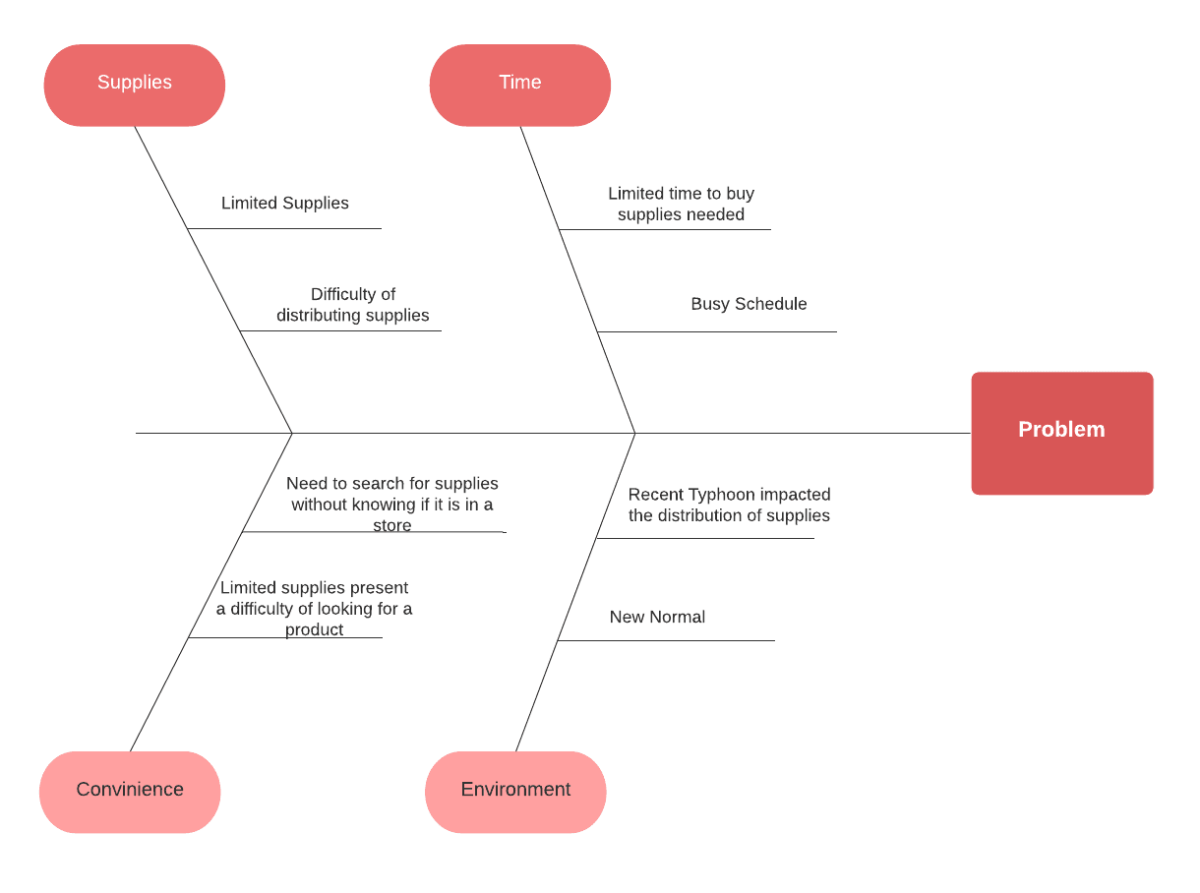

1. **Project Plan Schedule**

* To represent our schedule, we will be using a Gantt chart to represent the workings per sprint of our schedule. We will use the **scrum methodology** in making features and completing this system.
* **SPRINT 0** is defined as the dependencies and requirements for the backend needed for the system to start. This is usually composed of the Database and the API’s and services used as a third party to help our system in Production.

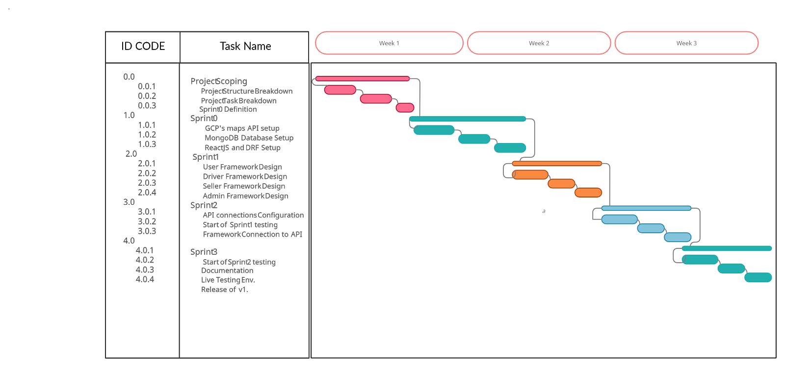

1. **System Definition**

- System Components

1. User details
2. Rider Details
3. Seller Details
4. Store Details
5. Payment Details
6. Product Details
7. Order Details
8. Reviews
9. Location Pointer(Using collaborative filtering based on Nearest Quality store)
10. Recommendation System
11. Nearest Customer System

--- I/O variables utilized using MySQL

1. User details
   * User number, firstname, lastname, preffered_name, address, contact details, reference number,  active_buyer, username, password, location.
2. Rider Details
   * Rider number, firstname, lastname, preffered_name, address, contact details, plate no,  active_rider, rider_vehicle,  username, password, currentlocation- separate table due to changes.
3. Seller details
   * Seller number, firstname, lastname, preffered_name, address, contact details, reference no,  active_seller, seller_store_no, username, password, location.
4. Store details
   * Store number, name, location, details, labels(e.g. Types of materials)FK.
5. Product details
   * Product no, Store_no(FK store), product description, type, quantity, price.
6. Payment Details
   * For now we will use Cash on Hand.

-- I/O variables using MongoDB (NoSQL Database)

1. Order Details
   * Order No, user, seller, product, location, address, rider details, payment details, tracking no., rider_coordinates.
2. Tracking Details
   * OrderNo, rider coordinates.
3. Reviews
   * Review No, store, product, seller, user, comment, timestamp.

 -- Calculated Fields by extracting data

**Location Pointer**

Nearest Location point for the user to see a range of quality stores based on the filtered products he/she chose. This has the option to relocate coordinates based on the quality review of each store.

**Recommendation System**

In order to make the app more user-friendly and interactive we added a recommendation system to suggest related products as well as budget friendly product for users to buy.

**Nearest Customer System**

In order to make the app easier for our riders to use, we added a nearest location pointer as mentioned above now for riders to get a series of customers nearby.

1. **Data Collection Process**

**Technique/s**

* The Data Gathering method done to collect sources and information was quite easy. All we have done was console to the Internet's Search engines and conducted Interviews. In regards to the Internet Search Engines, we made sure to utilize its full potential, ranging from using keywords in order to navigate through the information labyrinth and to get the necessary and accurate information that is to be needed In regards to Interviews, we conducted this Data Gathering through the means of chatting online or video calling. It is due to the current pandemic that we are limited to such an extent to resort into the means of online interaction rather than personal means. However, that does not mean the Interviews are less inaccurate, all we need is the information, not the informant

**Source/s**

Food Delivery Service is the concept of bringing food or any other commodities to a person’s doorstep. This is usually implemented by many fast-food chain restaurants around the globe and is currently growing in terms of service area due to the recent rise of the of COVID spread back when it resulted in an outbreak in the past year. People have been isolated in their homes and was mandated by the government to wear facial masks in order to protect themselves from contracting the COVID 19 Virus. Leaving their houses was not recommended by most governments of many countries especially those countries that have high risks and high amount of people who have contracted the said virus. This is to prevent people from contributing to the ongoing spread of the virus and to be able to resolve the outbreak as soon as possible.

While it is not uncommon to use food delivery services before the outbreak began, food and commodity delivery services has been in existence ever since Ancient Rome in the early 753 B.C. – 476 A.D. The idea of taking out food dates back to Ancient Rome, when Romans who didn’t have the luxury of having their own kitchen could get ready-to-eat food in street kitchens dubbed *thermopolia*.[1] Meanwhile, in ancient Aztec, vendors would sell food meant to be eaten on the go, such as *tamales,* in open-air markets. In 1889, the first pizza delivery was made by King Umberto I of Italy. The Indians also developed one of their first meal delivery system. It was called the dabbawalla meal delivery system. Because many workers didn’t have the luxury of time to eat lunch at home, many turned to *dabbawalas* which contains “home-cooked food” delivered to people’s places of work.

During the time of World War II, food delivery also rose to prominence due to the bombings executed by the Germans. The Women’s Volunteer Service for Civil Defense prepared and delivered meals for those lacked the means to cook. By the 1950s, restaurants opted to offering take-home meals to most of the middle class in the U.S. Milk delivery system was also popular in the 50’s and the 60’s as many homes did not have refrigerators and milk was easily perishable. With the growth of modern technology, there have been a lot of changes towards food delivery services over recent years. Most famous restaurants have introduced toll-free numbers so that customers can call on these numbers without being charged for the phone call. In addition, the concept of free food delivery to one’s homes was well-appreciated by customers. This way, not only could people call the restaurants for free but they can also get a hold of the food they ordered without any cost of transaction. This indicates that food delivery services play an important role in the modern food and restaurant industry, and due to the high level of competition with its competitors, this has proven to be a major factor that affects the demand of consumers.[2]

In the Philippines, the usage of prominent food delivery apps such as Foodpanda, GrabFood, Honestbee, etc. by the Filipinos has become a common practice for some families in the past year. They avoided leaving their houses when the lockdown first occurred in order to prevent the spread of the virus. Such systems were primarily developed using Android Studio for Android phones and Xcode for iPhones. Additionally, the usage of apps that caters to users who want to deliver groceries from the supermarket to their homes has become more prominent in the past year. Take for example the MetroMart app. The application delivers from a variety of stores including groceries, bakeries, electronics, pet care, and more. MetroMart is one of the first demand store deliveries in the Philippines.

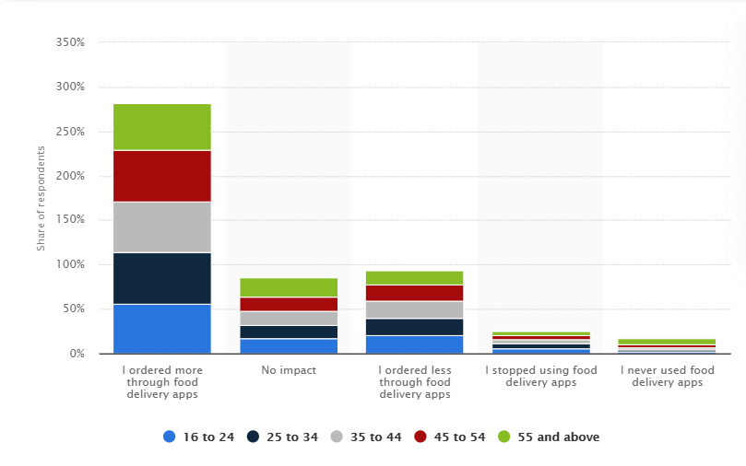

*Source:* [*https://www.statista.com/statistics/1147516/philippines-food-delivery-apps-usage-during-covid-19-by-age/*](https://www.statista.com/statistics/1147516/philippines-food-delivery-apps-usage-during-covid-19-by-age/)

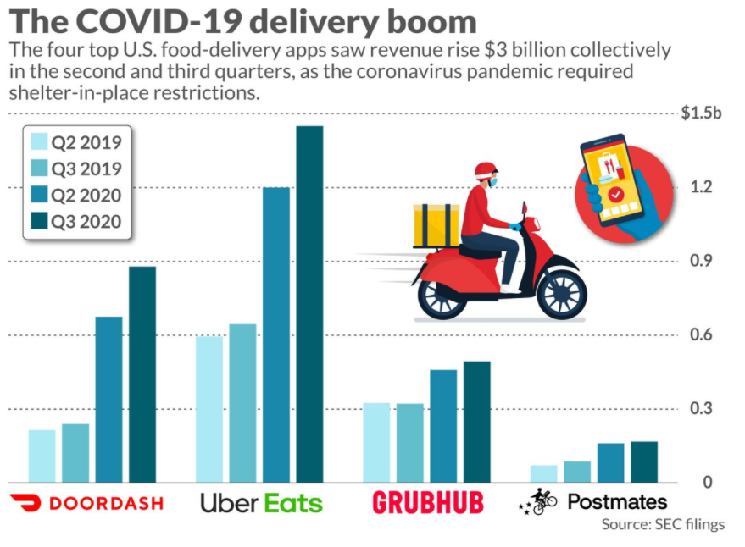

**GrabFood**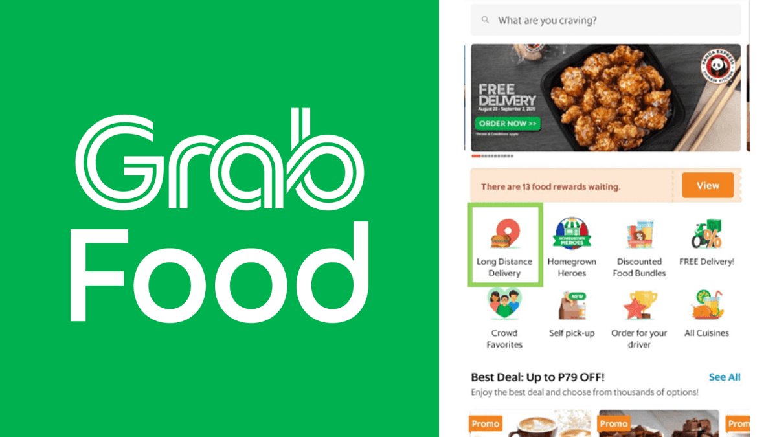

**FoodPanda**

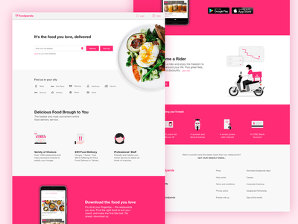

**HonestBee**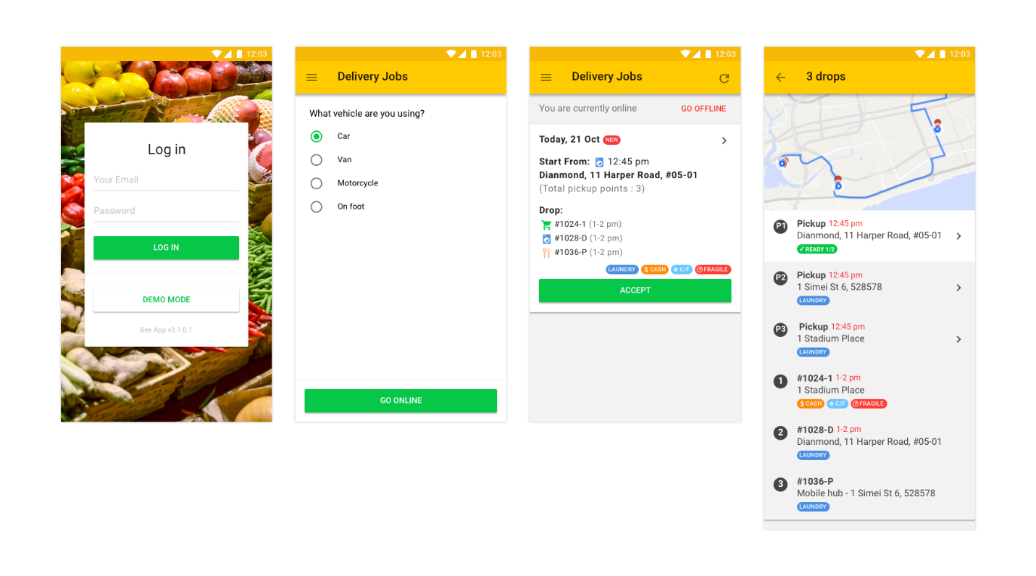

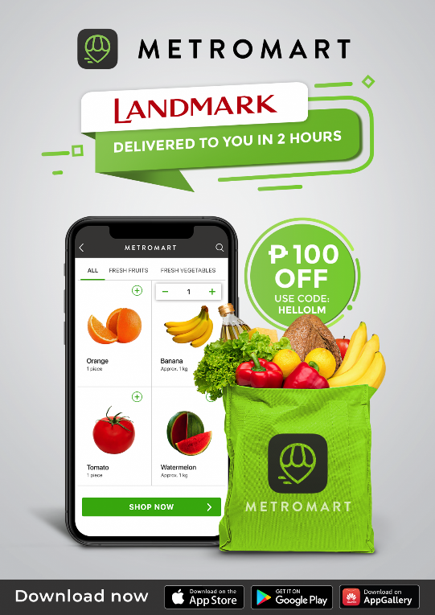

All four of these applications align with the specific and common goals that the Next Door Delivery application aims to deliver. Providing the public ease of access to countless stores, fast food restaurants, and more while using a smart phone is one of the main goals that the application is developed for. GrabFood, FoodPanda, HonestBee, MetroMart, and other food delivery applications are one of the many systems in which Next Door Delivery Application has taken inspiration from.

1. **Model Translation**

START system

*//Choices :Login or Signup*

get User email and password

IF login THEN

Check database User Entries THEN Compare

IF exist THEN load dashboard

IF as customer THEN

Grant options to Add items to Cart, Checkout

IF add to cart

Add products to card

Set product state to Cart

ELSE IF checkout

GET all items in cart THEN set state to CHECKOUT

DISPLAY product info to confirm order and ask to proceed

IF proceed

Set product state to Payment

ELSE go back

ELSE IF as rider

Customer details and orders to be delivered are listed

ELSE IF as seller

New product data are added database

updated products are updated in the database

ENDIF

ELSE

prompt an error message

ENDIF

ELSE

get User email and password and fill out user details

Data added to database

END IF

END system

**Summary of major system operations:**

1. Input User Details
2. Input Order Details
3. Fetch the Nearest Store from the User’s Location
4. Check for Available Riders
5. Fetch Rider Details and Location
6. Verify Product Details and Payment Details
7. Confirm Package as Delivered and Paid
8. Input Review

**-**-- Summary of major system operations

1. Input employee details
2. Compute the number of hours worked including the overtime if any
3. Compute the deductions
4. Compute gross pay
5. Compute net pay
6. Print pay slips and payroll report

**---** The following is the list of programming languages we use:

* + Python **–** In order for use to send and get request from our database without the need for our developers to do the crud statements, we created an API in Django Rest Framework.
  + Java – To run our mobile Application, Java is used as the base language to run React-Native.
  + React-Native – this is a primary extension used in java to have a responsive mobile application.
  + SQLite – this is the primary database used to store and fetch from our API.
  + Firebase – this database is primarily used as an alternative to MongoDB as the scale of our application is not necessarily wide.
  + GCP (Google Cloud Platform) – primarily used to retrieve Map APIs needed for this application.

--- The following is the development process of the system:

1. Input the personal details for each entity

a.1. Personal details of user

a.2. Personal details of rider

a.3. The list of their vehicles used

a.4. Personal details of Seller

a.5. The list of their Store and its personal details

1. Personalize Dashboard for each entity

b.1. Profile page

b.2. personalized dashboard for each entity using independent systems

1. Tracking System for logistics

c.1. Use Maps APIs from GCP (Google Cloud platform) for data dependencies needed for maps

c.2. Display directions and other necessary details like distance and polyline to guide user and rider to their designated shops using Distance Formula and the get request from Directions API using Android Maps API.

c.3. Keep track of your location by constantly updating the direction around you via get request from Directions API.

c.4. update directions given if the user has already passed that particular area via get request from Directions API.

1. Ordering System

d.1. have the basic interface such as cart, checkout payment, and order details for user entities to use.

d.2. Add some functionality to update and validate the orders via checking out and confirming the order.

d.3. Payment is cash on hand.

d.4. Generate receipt to be viewed in order details.

1. Nearest Customer System

e.1. Compute the distance between the rider and customer and the shop their going to fetch the goods from using Harvasine formula

e.2. Compute the perimeter area surrounding the driver then validate if e1 is within the perimeter of e2.

e.3. alter results of the API get via filter made with the algorithm above.

1. **Verification and Validation**

**USER**

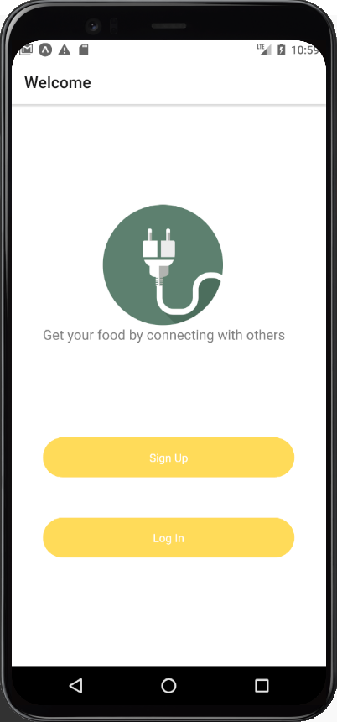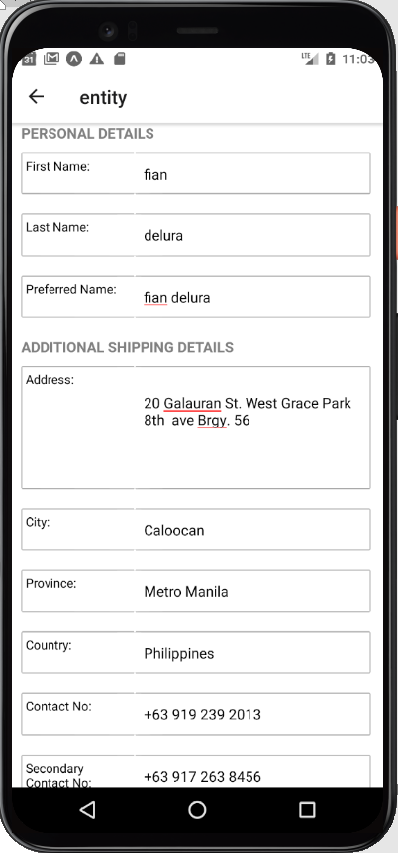

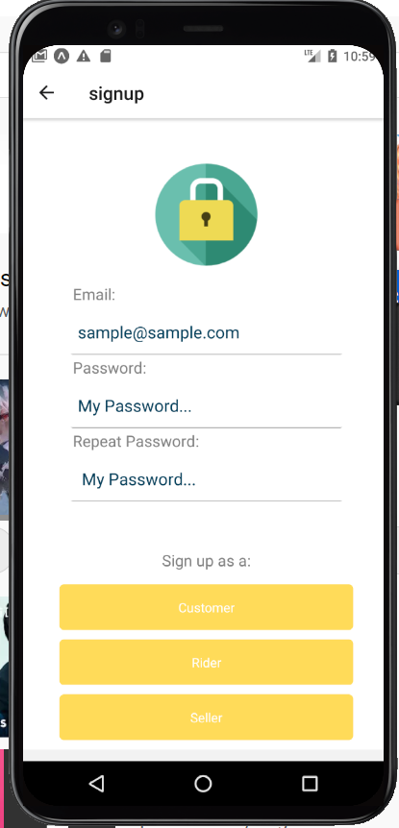

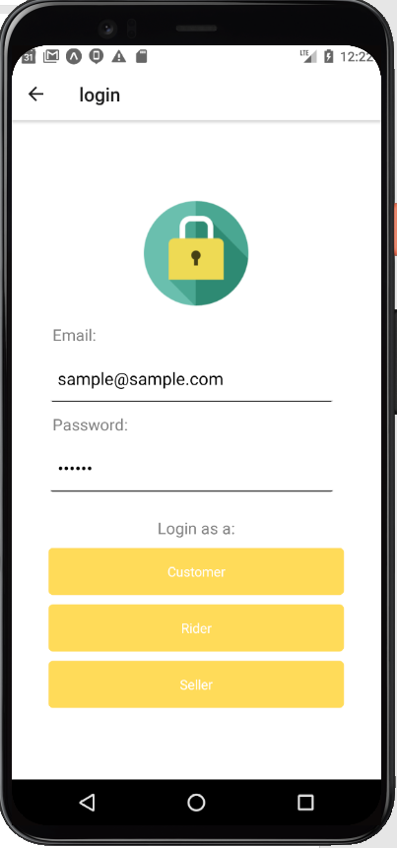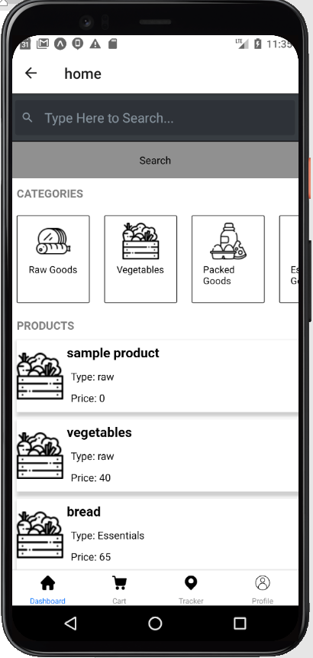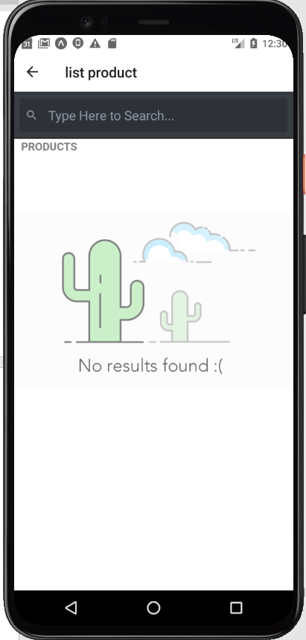

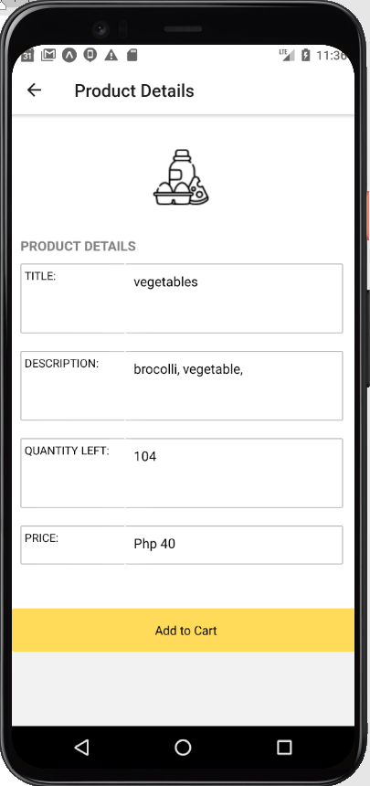

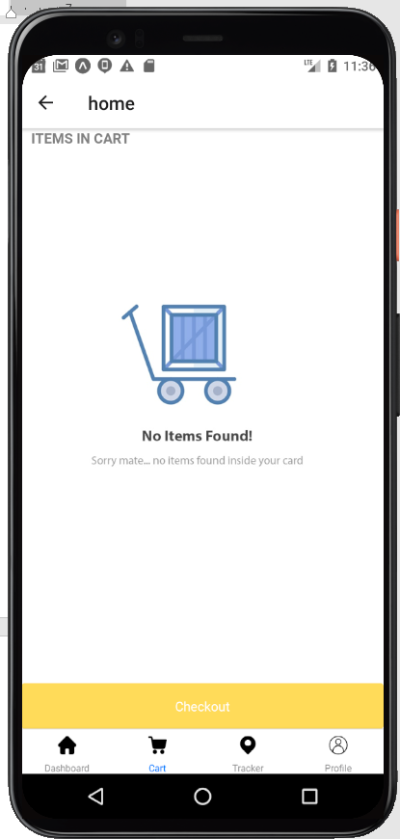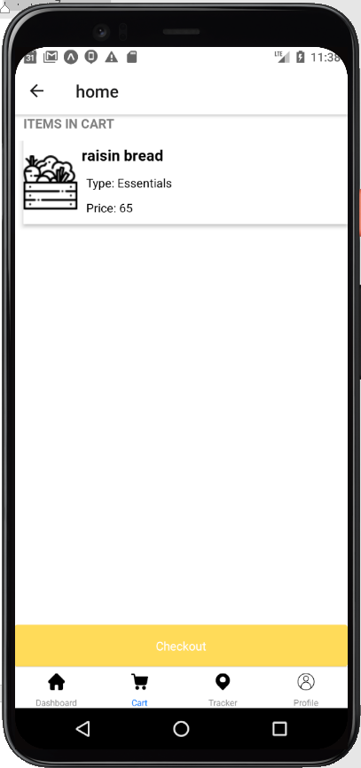

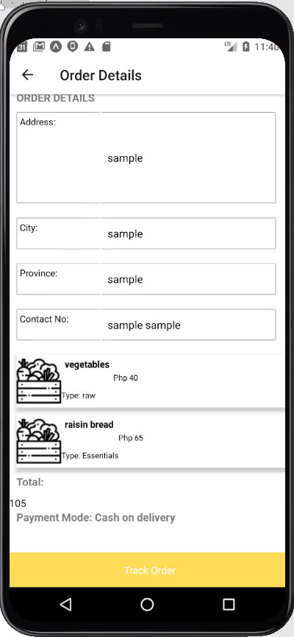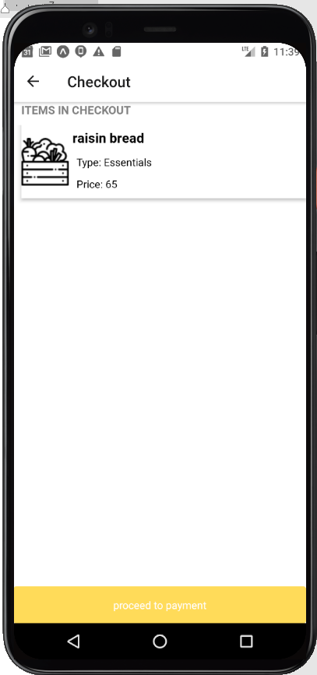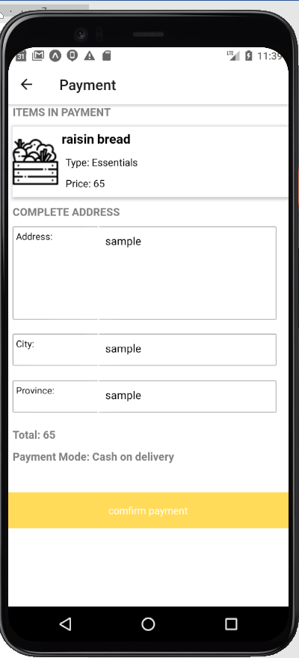

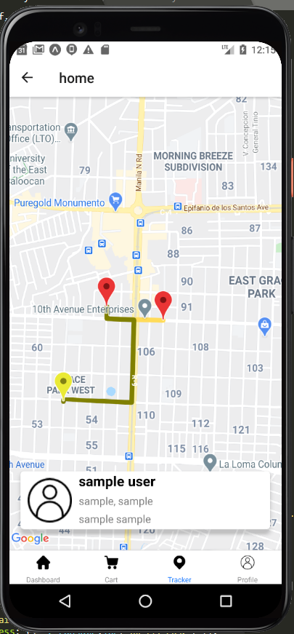

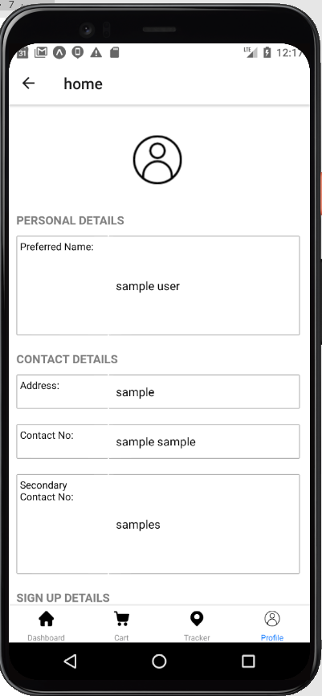

**RIDER**

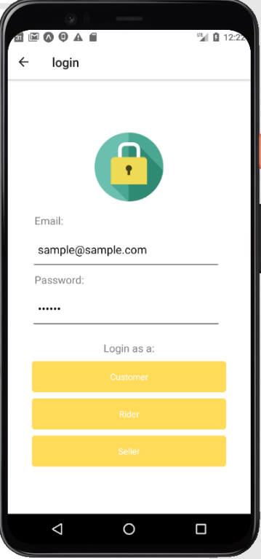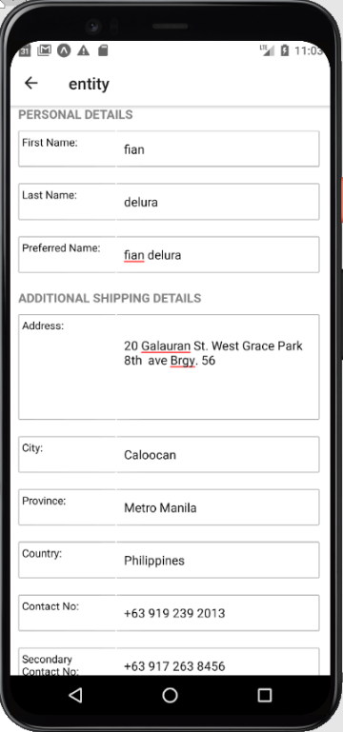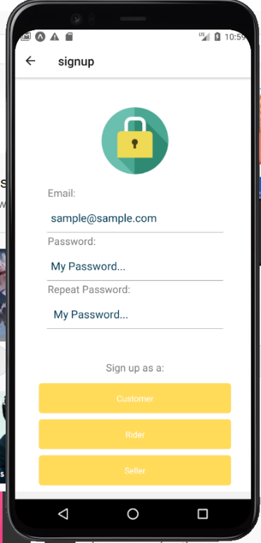

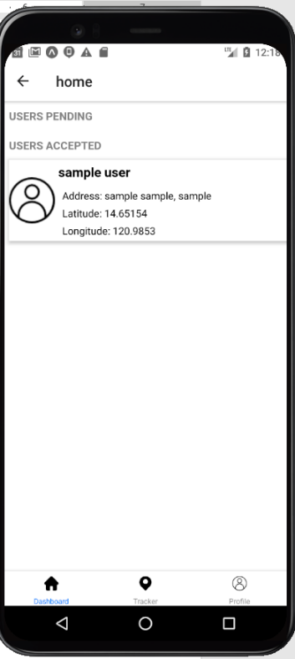

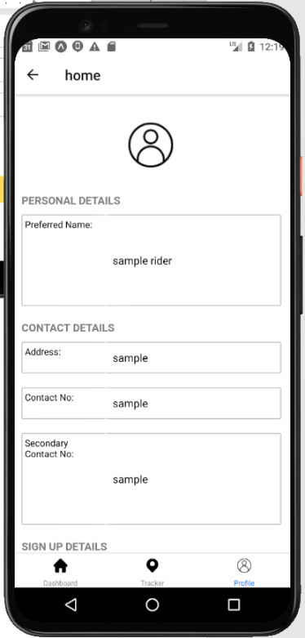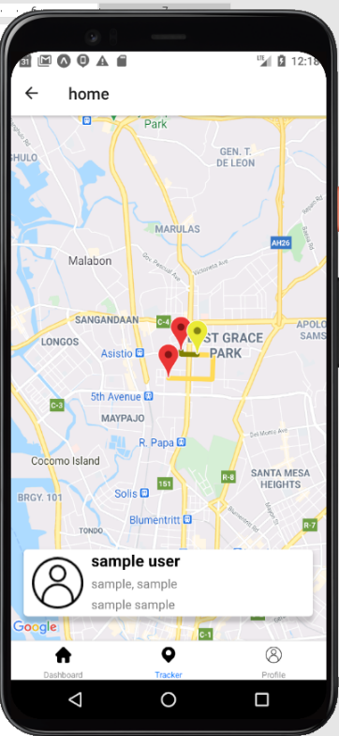

**SELLER**





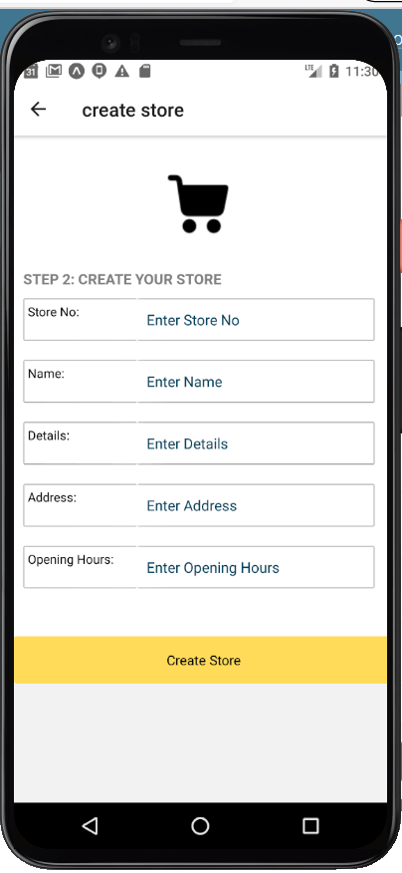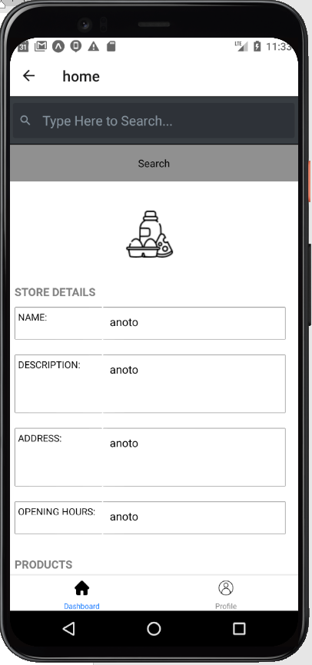

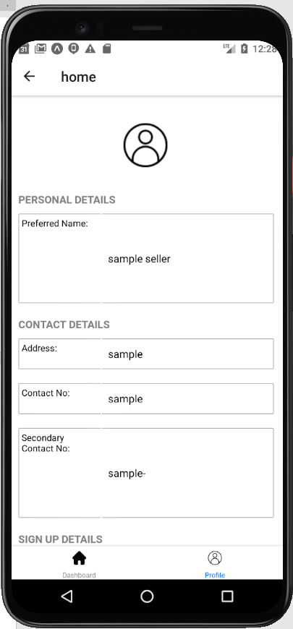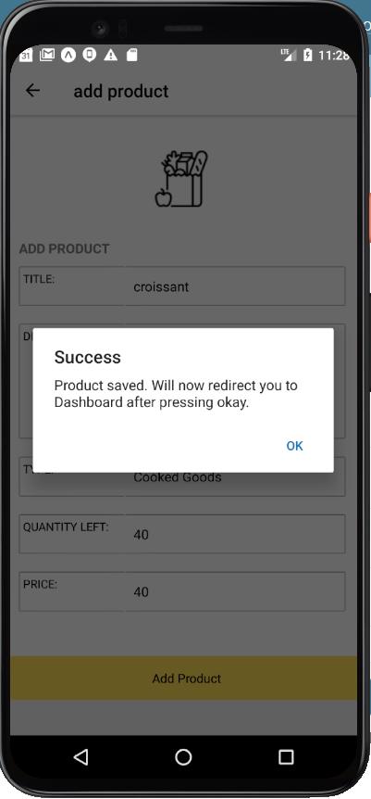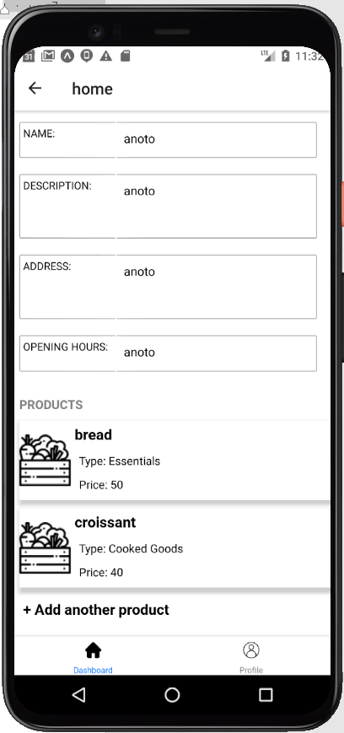

1. **Debugging Process**

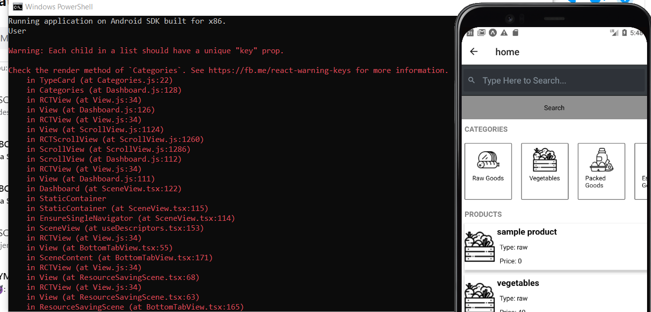

Since this is a warning, we provided unique keys garnered from the GET request for each Product Card a user can see from this instance. It is also used to reference each entity of where to get them from our list of products displayed.

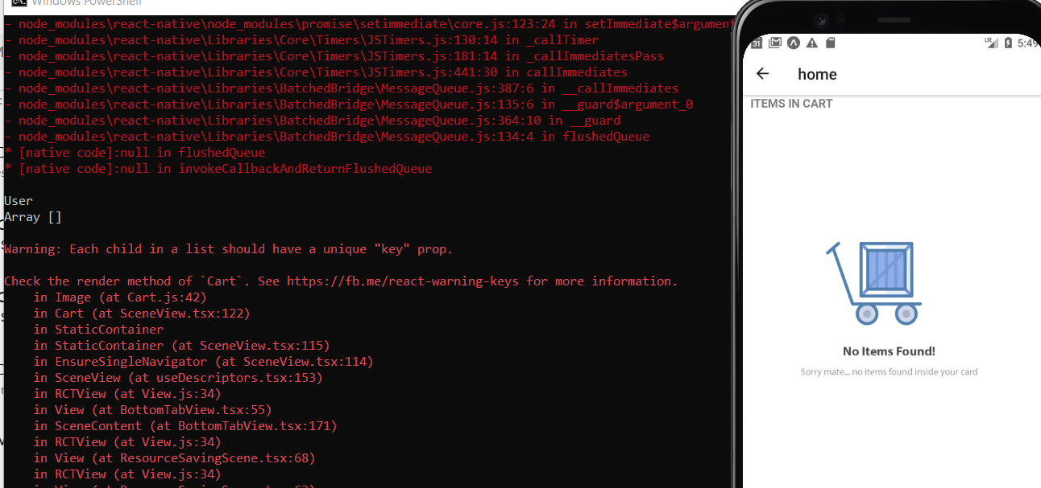

For user interface having null values, we provided a default screen to show user friendliness of our system. We also provided unique keys gathered from their PK(Primary keys) for each entity of products bought by the users.

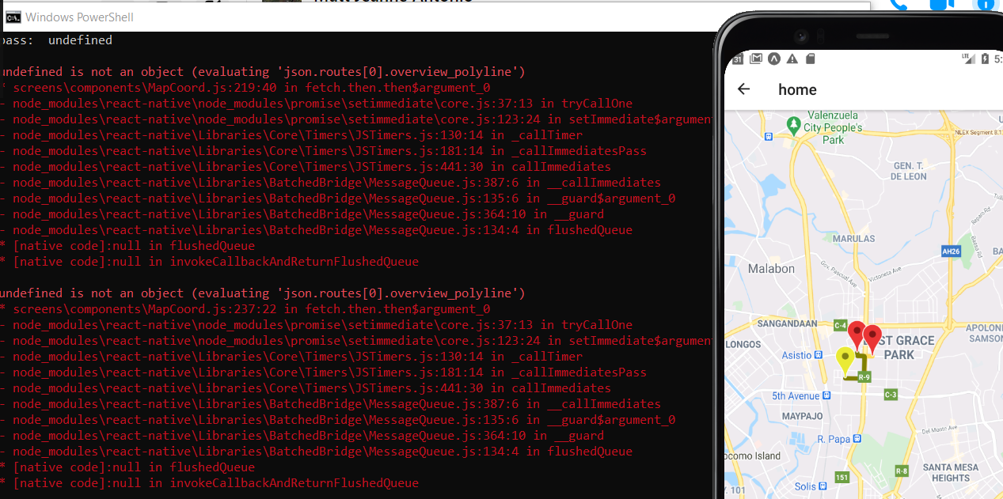

In this phase, we use a preloading technique since it takes to much load time and prep time to gather each request from each screen using Django rest framework and Directions API. By the time a user has landed a dashboard, the user request will then preload as well as each of the user information required. This will then help in loading time and display the user request for rider.

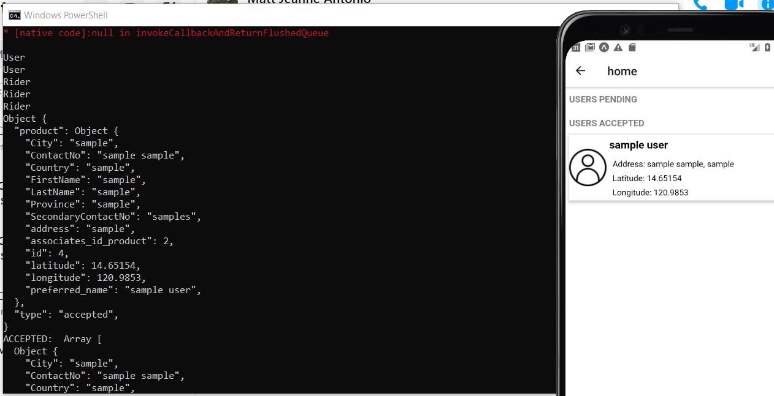

We often display our results gotten from each request via cmd. This is so that we can track each changes whether our formatting needs to be changed or not depending on the changed format of each request. This is the common rule for using the same screen for different users as our systems sticks to the DRY principle in coding best practices.

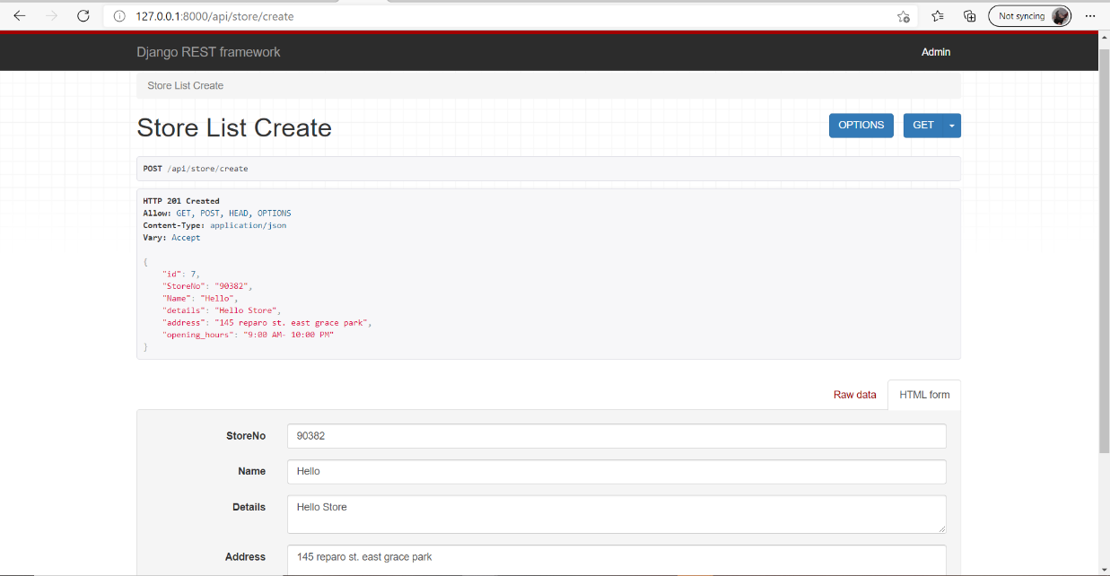

This is a sample development form where we test each of our created requests and models derived from our database. If one of the requests here fails, this can be debugged as it shows the error unlike when we test it from the frontend side which is react-native. Since we are on development mode, we need to use local host but if given a chance to deploy this in production, this will be given a domain name and can be used in different platforms.

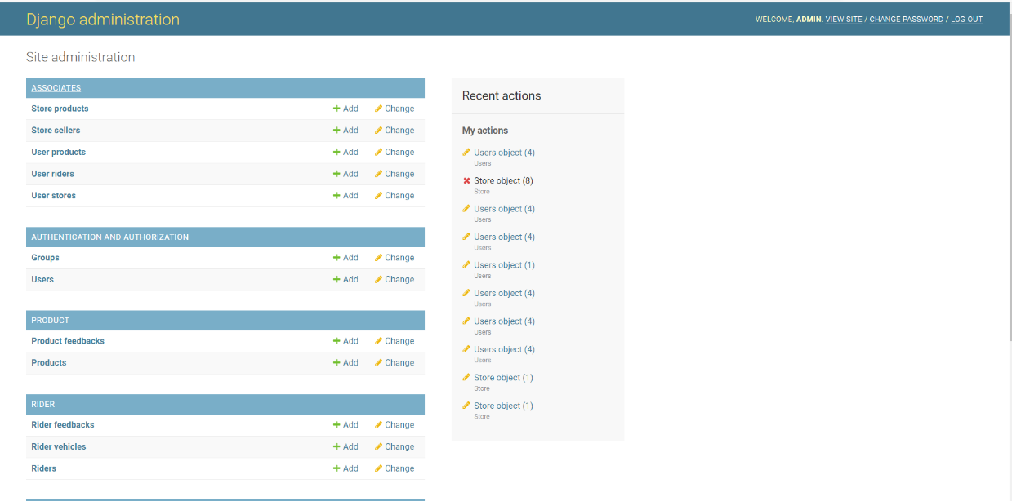

This is the overview of our API framework. we create objects and instances here to as a reference to our DB instance so that we don't need to access our DB anymore. This supports SQL cloud from google platform where if our version 2 is done, it will be changed to real-time from its current standalone feature.

1. **Testing Results**

**Survey Questionnaire**

Polytechnic University of the Philippines

College of Computer and Information Sciences

Sta. Mesa, Manila

Name (optional): Valenzuela, Erin Carlo T.

Date: February 24, 2021

Group No.: NexGen Academy Inc. – Electronic Grade Records System (e-Marka)

**General Directions:** Put a cross mark (X) on the box of your answer. Please follow the given legend below.

**Legend:**

**5** – Strongly Agree/Very Acceptable

**4** – Agree/Acceptable

**3** – Satisfied

**2** – Disagree/Not Acceptable

**1** – Strongly Disagree/Not very Acceptable

|  |  |  |  |  |  |
| --- | --- | --- | --- | --- | --- |
| **Accuracy** | **5** | **4** | **3** | **2** | **1** |
| 1. NEXT DOOR APP gives my desired output. | **X** |  |  |  |  |
| 2. The sequence of pages is clear |  | **X** |  |  |  |
| 4. The app was clear in its instructions  and I easily understood how to use it. |  | **X** |  |  |  |
| 5. The app is how they presented it. | **X** |  |  |  |  |
| **User-friendliness** |  |  |  |  |  |
| 6. The system is easy to use |  | **X** |  |  |  |
| 7. The overall functionality of the app  guides users in exploring the app more  efficiently | **X** |  |  |  |  |
| **Efficiency** |  |  |  |  |  |
| 8. Looking for alternative options is easier with this system. | **X** |  |  |  |  |
| 9. Using this system made it more convenient to shop. | **X** |  |  |  |  |
| 10. Buying essentials are faster with the use of the system. |  | **X** |  |  |  |
| 11. Navigation buttons can be used for transitions | **X** |  |  |  |  |
| 12. The system has the capability to track my orders. | **X** |  |  |  |  |
| 13. The system uses less power which makes it battery-efficient | **X** |  |  |  |  |
| 14. The system has the capability to suggest ideal options to the user. | **X** |  |  |  |  |
| **Functionality** |  |  |  |  |  |
| 15. NEXT DOOR APP is useful in buying and selling essentials | **X** |  |  |  |  |
| 16. NEXT DOOR APP makes transactions of goods easier | **X** |  |  |  |  |
| 17.NEXT DOOR APP guides users in choosing the best options |  | **X** |  |  |  |
| 18. NEXT DOOR APP guides seller to have an alternative option of selling essentials. |  | **X** |  |  |  |

**Survey Questionnaire**

Polytechnic University of the Philippines

College of Computer and Information Sciences

Sta. Mesa, Manila

Name (optional):

Date: February 24, 2021

Group No.: NexGen Academy Inc. – Electronic Grade Records System (e-Marka)

**General Directions:** Put a cross mark (X) on the box of your answer. Please follow the given legend below.

**Legend:**

**5** – Strongly Agree/Very Acceptable

**4** – Agree/Acceptable

**3** – Satisfied

**2** – Disagree/Not Acceptable

**1** – Strongly Disagree/Not very Acceptable

|  |  |  |  |  |  |
| --- | --- | --- | --- | --- | --- |
| **Accuracy** | **5** | **4** | **3** | **2** | **1** |
| 1. NEXT DOOR APP gives my desired output. |  | X |  |  |  |
| 2. The sequence of pages is clear | X |  |  |  |  |
| 4. The app was clear in its instructions  and I easily understood how to use it. |  | X |  |  |  |
| 5. The app is how they presented it. | X |  |  |  |  |
| **User-friendliness** |  |  |  |  |  |
| 6. The system is easy to use | X |  |  |  |  |
| 7. The overall functionality of the app  guides users in exploring the app more  efficiently | X |  |  |  |  |
| **Efficiency** |  |  |  |  |  |
| 8. Looking for alternative options is easier with this system. | X |  |  |  |  |
| 9. Using this system made it more convenient to shop. | X |  |  |  |  |
| 10. Buying essentials are faster with the use of the system. |  | X |  |  |  |
| 11. Navigation buttons can be used for transitions | X |  |  |  |  |
| 12. The system has the capability to track my orders. | X |  |  |  |  |
| 13. The system uses less power which makes it battery-efficient | X |  |  |  |  |
| 14. The system has the capability to suggest ideal options to the user. |  | X |  |  |  |
| **Functionality** |  |  |  |  |  |
| 15. NEXT DOOR APP is useful in buying and selling essentials | **X** |  |  |  |  |
| 16. NEXT DOOR APP makes transactions of goods easier | X |  |  |  |  |
| 17.NEXT DOOR APP guides users in choosing the best options | X |  |  |  |  |
| 18. NEXT DOOR APP guides seller to have an alternative option of selling essentials. |  | X |  |  |  |

**Survey Questionnaire**

Polytechnic University of the Philippines

College of Computer and Information Sciences

Sta. Mesa, Manila

Name (optional): Olivar, Joseph Fernan S.

Date: February 24, 2021

Group No.: NexGen Academy Inc. – Electronic Grade Records System (e-Marka)

**General Directions:** Put a cross mark (X) on the box of your answer. Please follow the given legend below.

**Legend:**

**5** – Strongly Agree/Very Acceptable

**4** – Agree/Acceptable

**3** – Satisfied

**2** – Disagree/Not Acceptable

**1** – Strongly Disagree/Not very Acceptable

|  |  |  |  |  |  |
| --- | --- | --- | --- | --- | --- |
| **Accuracy** | **5** | **4** | **3** | **2** | **1** |
| 1. NEXT DOOR APP gives my desired output. | X |  |  |  |  |
| 2. The sequence of pages is clear | X |  |  |  |  |
| 4. The app was clear in its instructions  and I easily understood how to use it. |  | X |  |  |  |
| 5. The app is how they presented it. | X |  |  |  |  |
| **User-friendliness** |  |  |  |  |  |
| 6. The system is easy to use | X |  |  |  |  |
| 7. The overall functionality of the app  guides users in exploring the app more  efficiently | X |  |  |  |  |
| **Efficiency** |  |  |  |  |  |
| 8. Looking for alternative options is easier with this system. | X |  |  |  |  |
| 9. Using this system made it more convenient to shop. | X |  |  |  |  |
| 10. Buying essentials are faster with the use of the system. | X |  |  |  |  |
| 11. Navigation buttons can be used for transitions | X |  |  |  |  |
| 12. The system has the capability to track my orders. | X |  |  |  |  |
| 13. The system uses less power which makes it battery-efficient | X |  |  |  |  |
| 14. The system has the capability to suggest ideal options to the user. |  | X |  |  |  |
| **Functionality** |  |  |  |  |  |
| 15. NEXT DOOR APP is useful in buying and selling essentials | **X** |  |  |  |  |
| 16. NEXT DOOR APP makes transactions of goods easier | X |  |  |  |  |
| 17.NEXT DOOR APP guides users in choosing the best options | X |  |  |  |  |
| 18. NEXT DOOR APP guides seller to have an alternative option of selling essentials. |  | X |  |  |  |

1. **Conclusion and Recommendation**

**---** The Next Door App helps increase convenience within users as according to the survey mentioned above. Therefore the efficiency it provides helps cater customers at a level of their everyday lives making it more convenient and more efficient which is the primary goal of our system to help cater the simple needs that can be generated in a pattern.

**-**-- The recommendations of this group of developers for its development is to first expand the scale of customers to increase their preferences. While increasing their preferences, this app will be able to cater the needs more efficiently since recommendation systems need a core feature to help analyze customer preferences not just on recent searches but also their feedback therefore expanding our recommendation system functionality to sentiment analysis using Artificial Neural Networks.

1. Retrieved Feb. 19, 2021. https://www.spot.ph/eatdrink/the-latest-eat-drink/81524/food-delivery-history-a3284-20200325
2. Retrieved Feb. 19, 2021. https://folo.my/blog/what-is-a-food-delivery-service